Defect Report

Website: <https://www.evozon.com/>

Number of Defects:6

Test environment

The website was tested on Microsoft Edge 42.17134.1.0 and on Google Chrome Version 73.0.3683.103(64-bit).

1.Wrong contact information written on the front page of the website

The last contact information regarding the location and the telephone numbers the company can be accessed with are wrong, Rannersdorf, Austria T: +43 699 1277-0347 and Nagoya, Japan T: +81 52 7747-399

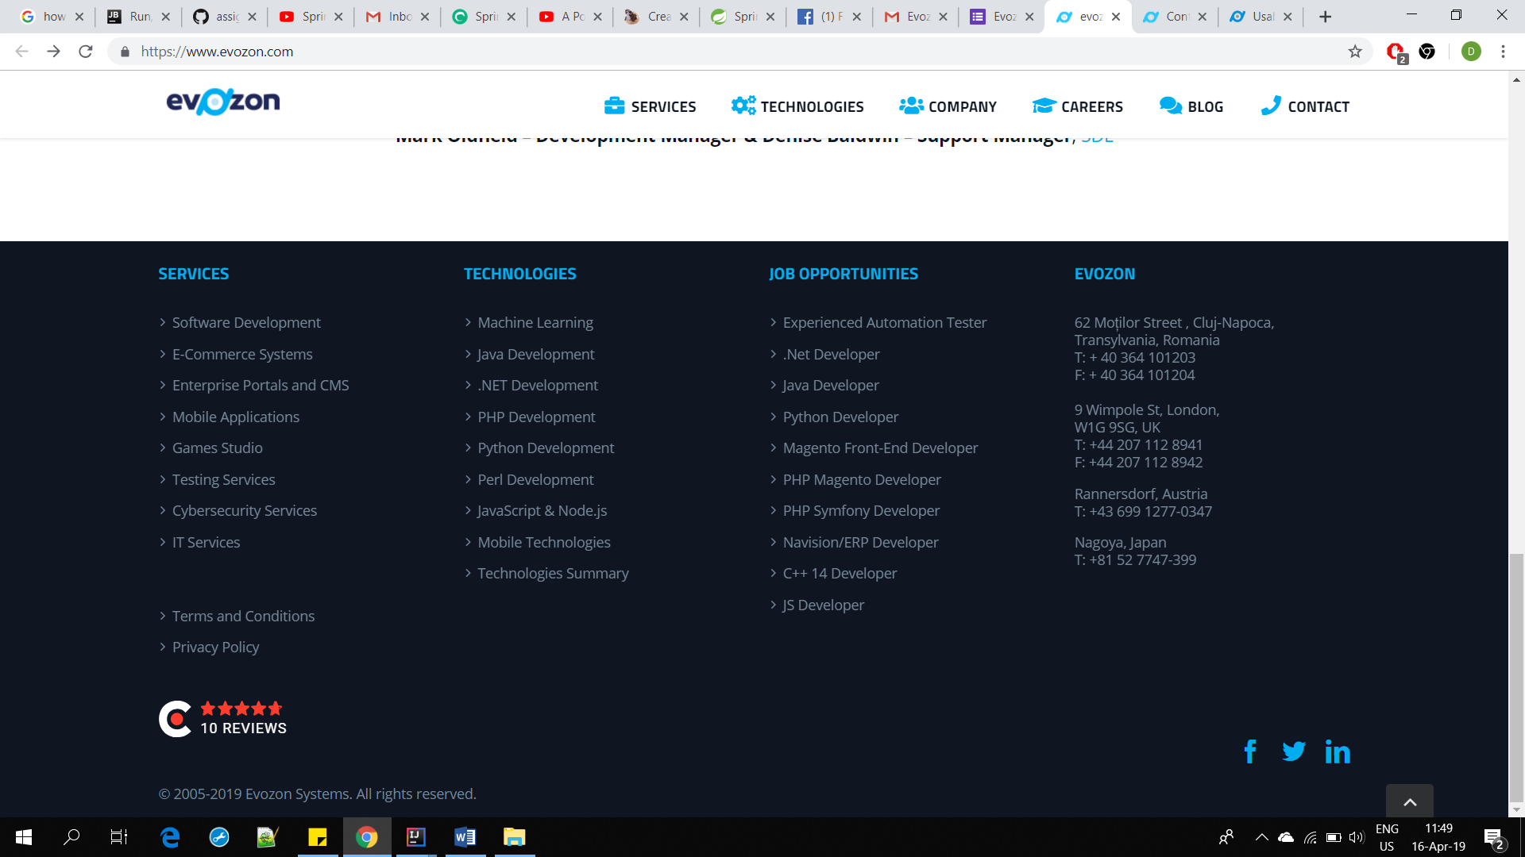

On a quick google search the number appears to belong to the company CustomSoft.

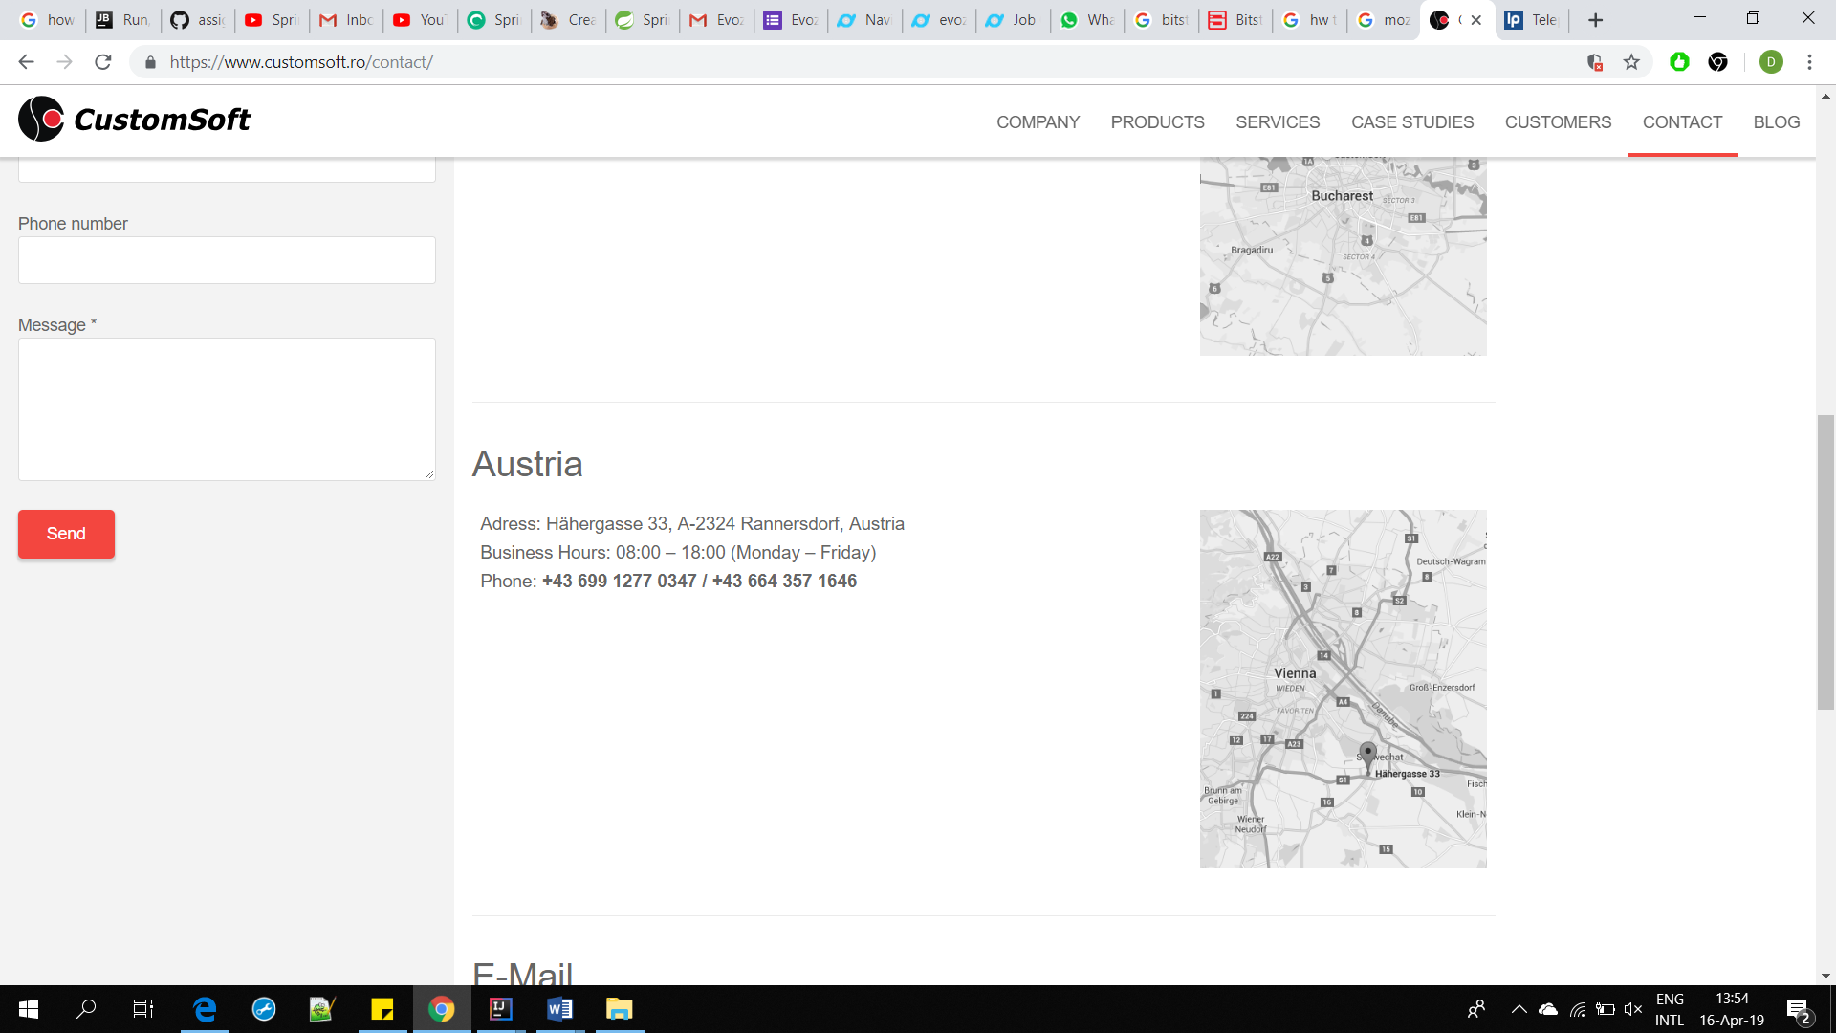

On the actual contact page the contacts are different.

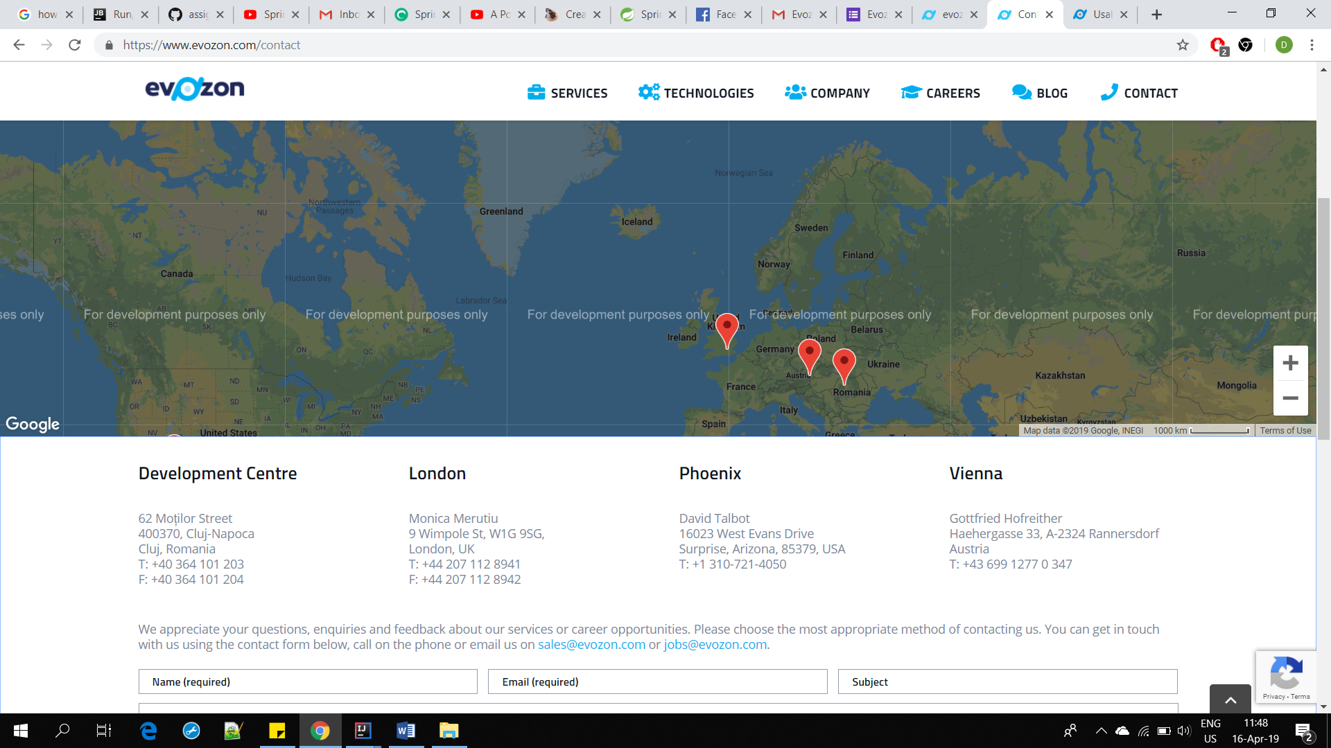

2. The job opportunities from the front page do not advertise all the available opportunities

As seen in the photo below(Photo1) the job opportunities are listed however if we check the page (photo2)we can see that there are two more job opportunity that do not appear : React/React Native Developer and Node.js developer, which is also written wrong and does not fit with the rest of the pattern.(Developer is written in small case when it should be big case)



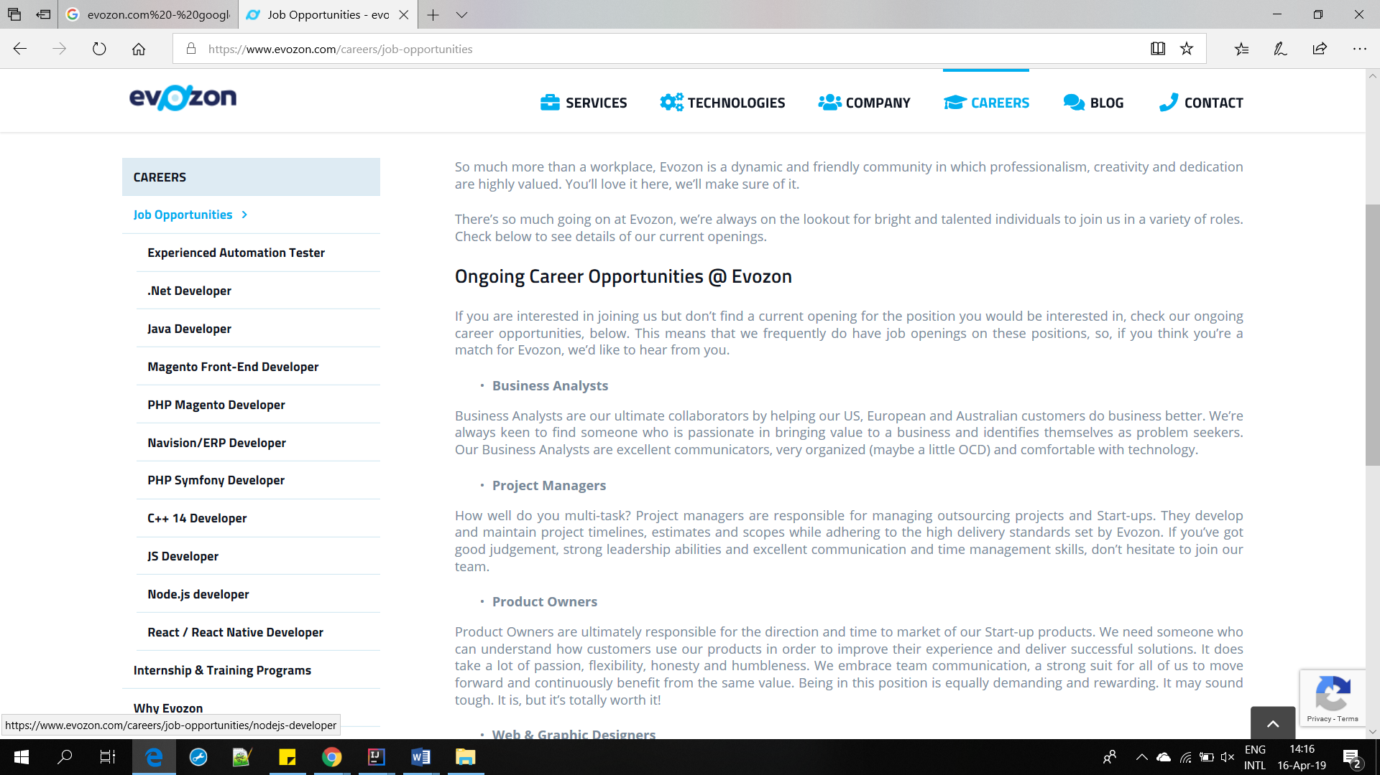

3. Map does not load correctly

This bug appeared on the page : <https://testing.evozon.com/contact>.

It appears that if a client wishes to consult the location of the headquarters in Romania they could not find it because the map data from Google Map is not loaded correctly.

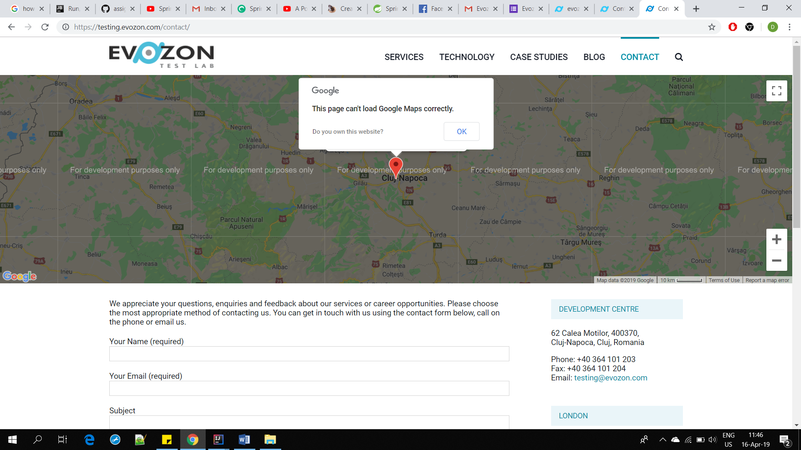

4. Wrong format of text and wrongly worded phrase.

As you can see below the text in the red box is bolded and while it does catch attention it looks misplaced in contrast with the text below.

Also the text is written in first person, “I’m looking”, “I mean ” and the text in itself seems to be scattered and does not have an ending point or conclusion.

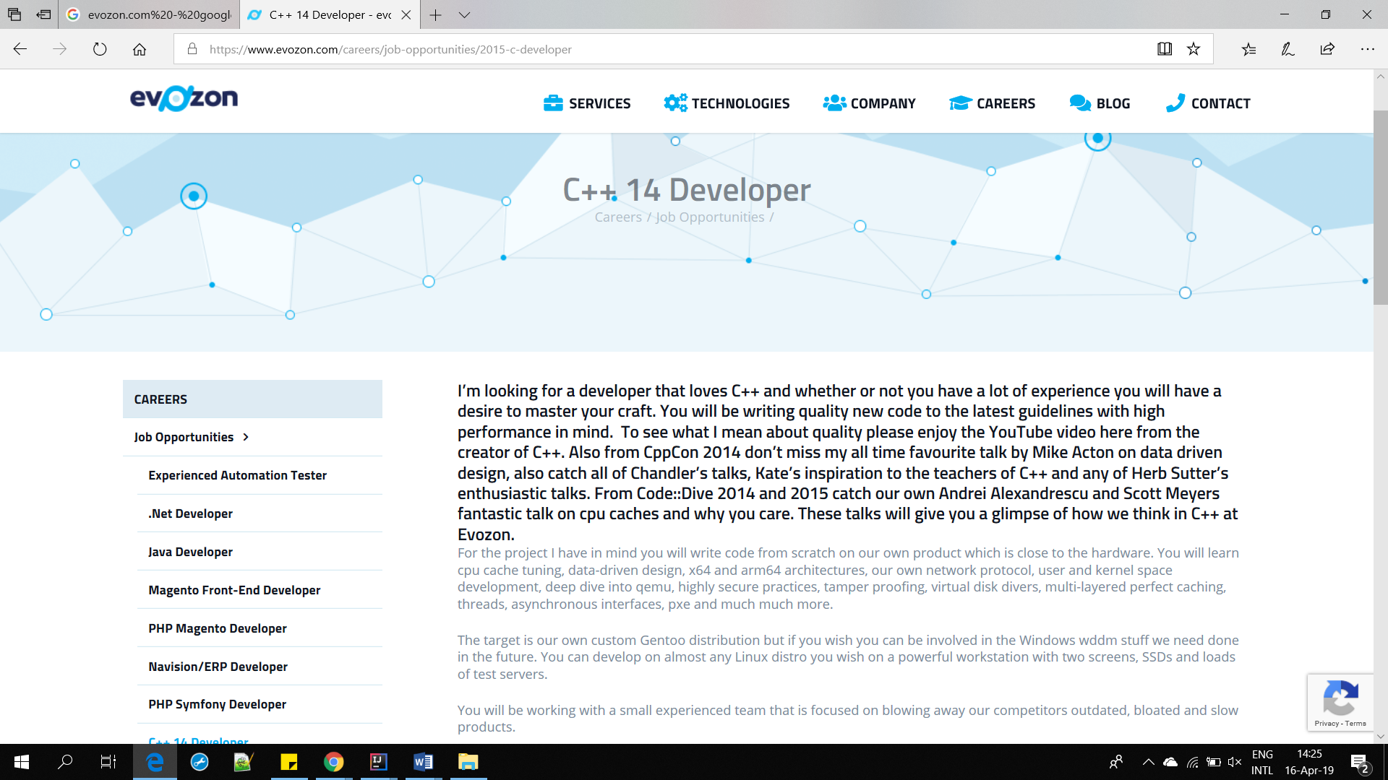

5. When applying to become a C++14 developer only one field is required

The email address field is required to be completed when applying for a position on C++ developer.

This should be changed as it could lead to numerous persons sending the same application from different email addresses.

Solution would be to require also a name and a subject in order to fill in the application.

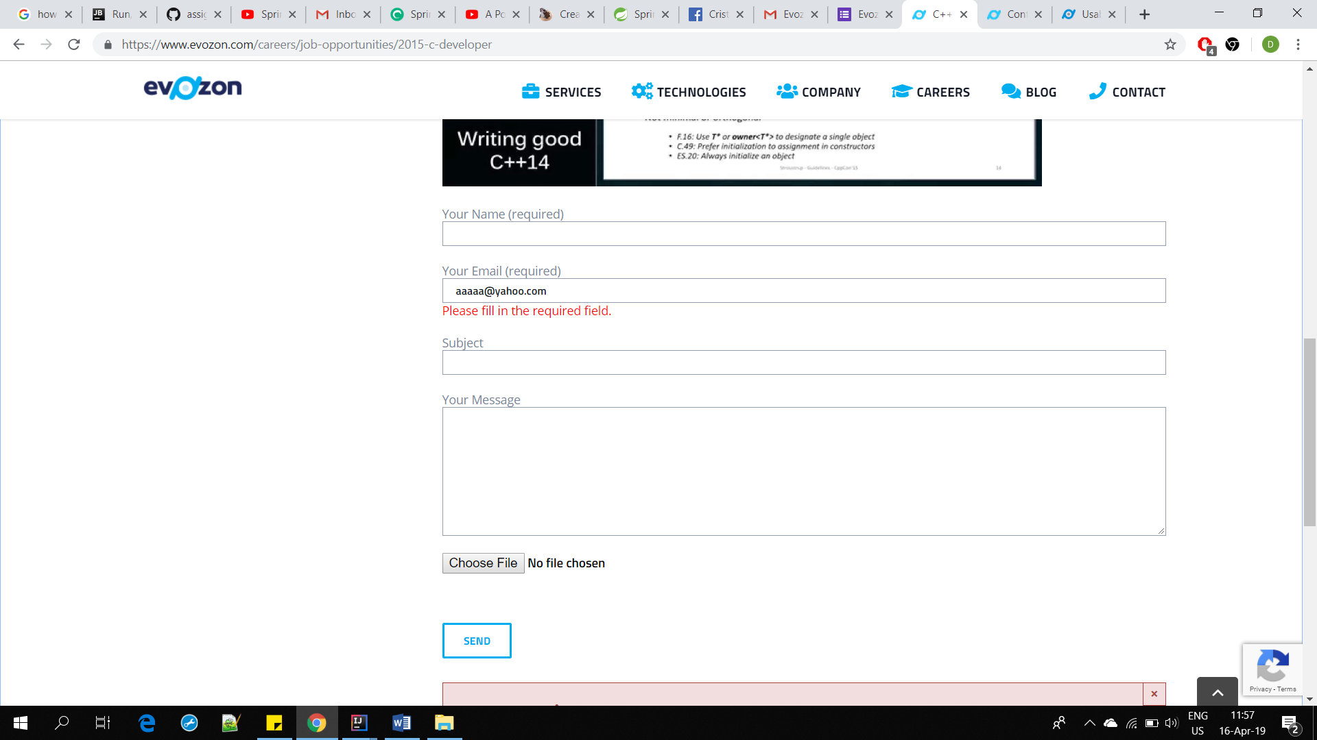

6.Difficult to read text

The text on some pages is grey on white and it is difficult to read it because the eyes take longer to focus on it and the contrast is barely existing.

Solution: A different choice of colour.

Examples:

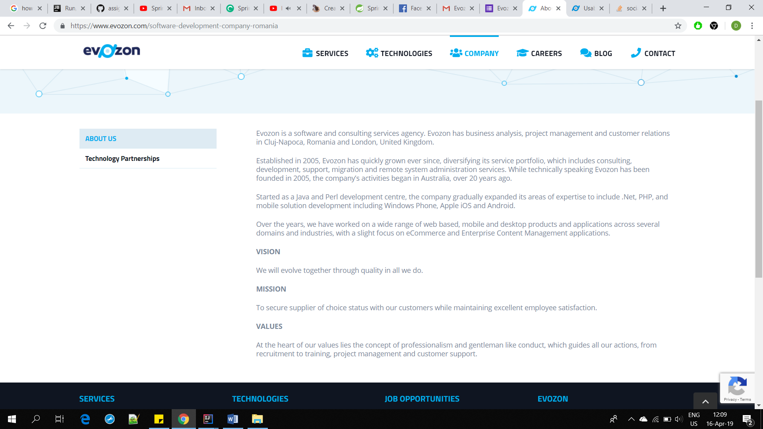

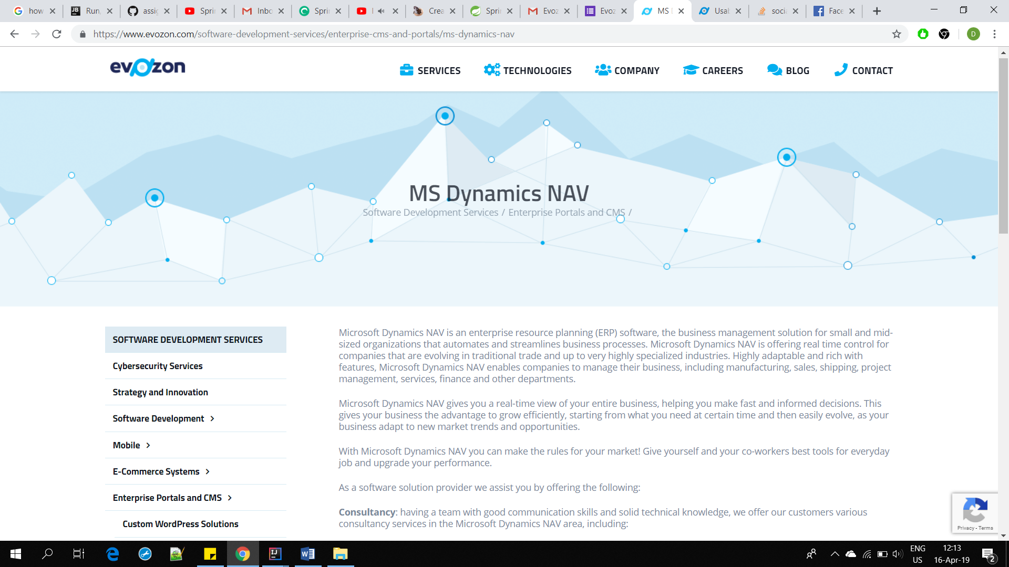

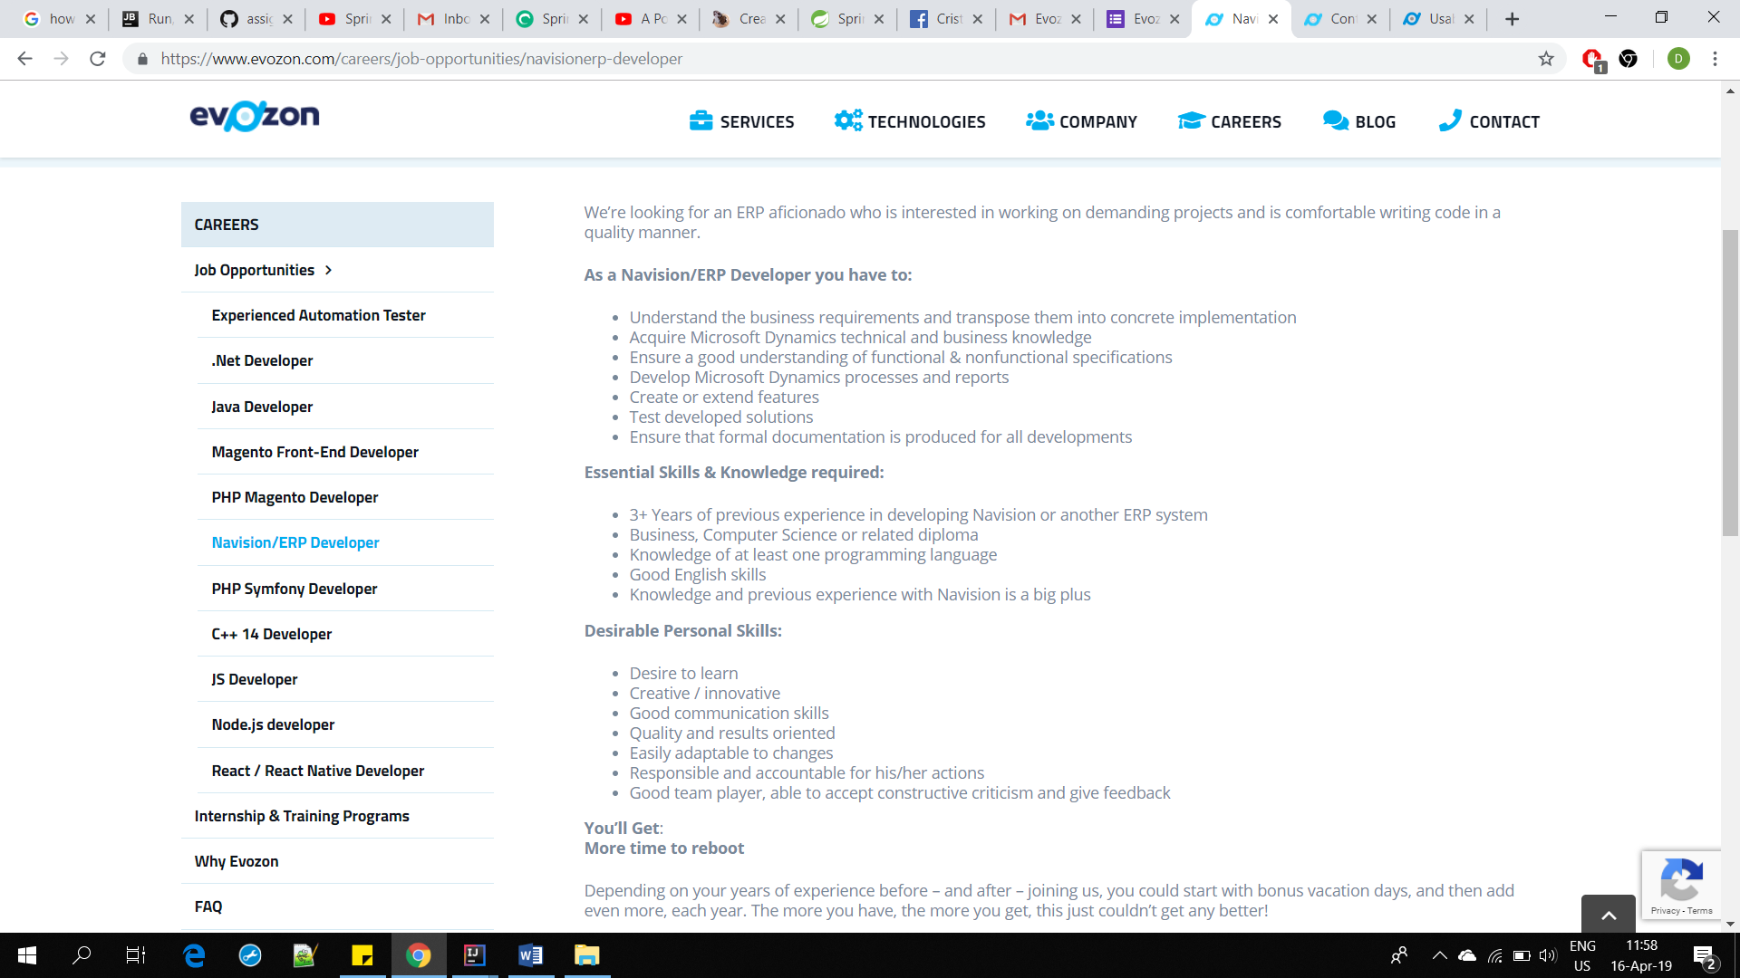

In this photo the important text is not standing out and it takes a while for the eye to catch the important parts of this text.

But on some pages the contrast between black and grey is strong and could make some people jump over some paragraphs.

